Physics 30 Lesson 24 Electromagnetic Waves
On April 11, 1846, Michael Faraday was scheduled to introduce Sir Charles Wheatstone at a meeting of the Royal Society of London. Unfortunately, Wheatstone had a bad case of stage fright and took off just before his lecture was to begin. As a result, Faraday was forced to give an unprepared lecture to the Royal Society of London. Faraday always gave well-prepared lectures punctuated by spectacular demonstrations, but he was totally unprepared for Wheatstone’s departure. As a result, Faraday was forced to spend an unrehearsed hour speculating on the future.

Faraday commented on an 1845 discovery he made concerning the change of polarization caused in light passing through heavy glass when exposed to external magnetic fields. He uncharacteristically speculated on the possible interrelationship between light and magnetism.

Unfortunately, Faraday did not possess the background or required talent in mathematics required to advance this idea. Besides, his time and energy were consumed by other interests. It would be ten years before a young theoretician named James Clerk Maxwell (1831–1879) would pursue a study of the possible connection between light and magnetism. You have probably never heard of Maxwell, but he was perhaps the finest theoretical physicist there has ever been. In 1855, Maxwell began to make his impression upon the face of science in England. Two years after graduating from Cambridge University, Maxwell began to examine Faraday’s possible connection between light and magnetism.

The principles of electromagnetism
Maxwell began by studying the two known principles of electromagnetism. As we learned in Lessons 19 and 21, Oersted and Ampere had discovered the relationship between current carrying conductors and induced magnetic fields:
A constant electric current in a conductor induces a uniform, constant magnetic field that circles the conductor. The electric current and magnetic field are perpendicular.

And, as we saw in Lessons 22 and 23, Henry and Faraday discovered the converse relationship:
When a conductor moves through a perpendicular magnetic field, a uniform, constant current is induced in the conductor.

In both principles, a conductor is one of the essential ingredients. Insulators, on the other hand, resist the flow of electric current. Maxwell wanted to know if electricity could be induced in an insulator in the presence of an external magnetic field. Maxwell discovered that a newly introduced magnetic field did cause a momentary shift of charges in the insulator, but the strong internal attractive forces quickly pulled the charges back into place. This confirmed Maxwell’s suspicion that the changing magnetic field would induce a current in any object.
Maxwell extrapolated his ideas to Ampere’s and Faraday’s principles of electromagnetism. Where the original principles were limited to a conductor, Maxwell did not see a need for a conductor – electric and magnetic fields could exist in space. He changed Ampere’s principle of magnetic induction to:
A changing electric field in space will generate a changing magnetic field that is perpendicular to the electric field.

He also changed Faraday’s principle of electromagnetic induction to:
A changing magnetic field in space will generate a changing electric field that is perpendicular to the magnetic field.

Note how the two principles work together: A changing electric field induces a changing magnetic field which induces a new changing electric field which induces a new changing magnetic field which …

Propagation of electromagnetic waves
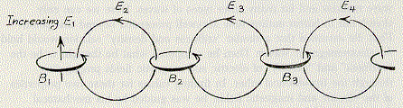
Maxwell’s mathematical theories presented an argument for electric and magnetic waves in space. Starting with an oscillating (changing) electric field in space, Maxwell could then explain how his electromagnetic waves could be generated. In the diagram to the right, an increasing electric field E₁ induces an increasing magnetic field B₁ which induces an increasing electric field E₂ which induces an increasing magnetic field B₂ and so on … forever. The result would be a self-generating series of changing fields radiating outward into space. In other words, this would be an electromagnetic wave.

Another way to visualise an electromagnetic wave is shown in the diagram to the right. 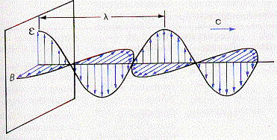One component would be a series of increasing and decreasing electric fields (ε) and the other component would be a corresponding series of increasing and decreasing magnetic fields (β) running perpendicular to the electric fields. The electromagnetic wave would propagate (move) in a direction perpendicular to both the electric and magnetic fields. Electromagnetic radiation (EMR) could travel through a vacuum as it did not require a medium and it could be polarized since it was transverse in nature. (See Pearson pages 641 to 647 for a discussion about Maxwell’s discovery.)

Maxwell’s predictions
Not only did Maxwell correctly predict the existence of electromagnetic waves, his equations also allowed him to make some predictions about the wave’s properties:
- The primary cause of all electromagnetic waves is an accelerating electric charge. As an electric charge oscillates/accelerates, electrical energy will be lost, and an equivalent amount of energy will be radiated outward in the form of oscillating electric and magnetic fields.
- When the electric charge is accelerated in periodic motion, the frequency of oscillation of the charge will correspond exactly to the frequency of the electromagnetic wave that is produced.
- All electromagnetic waves will travel at a speed of 310 740 000 m/s and obey the universal wave equation (c = fλ). (Note that Maxwell's theoretical prediction was not far from today's currently accepted value of 3.00 x 10⁸ m/s.)
- The oscillating electric and magnetic fields will always be perpendicular to each other and perpendicular to the direction of propagation of the wave.
- Electromagnetic waves should show all the phenomena associated with transverse waves: interference, diffraction, refraction, and polarization.
- Electromagnetic waves should produce pressure when they came in contact with a surface.

Hertz confirms electromagnetic waves
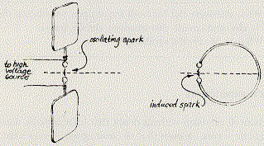
Maxwell was a theoretical genius but he was not a research scientist – he lacked the ability to experimentally verify his own predictions. In 1888, a German scientist named Heinrich Hertz would come to his rescue. Hertz was a gifted researcher. In 1888, he conducted an experiment designed to verify Maxwell’s ideas. Using an induction coil to produce a spark across a gap, Hertz was able to detect a spark jumping across the same type of gap on a wire across the room. (See Pearson pages 644 and 645.) The changing electric field produced by the oscillating sparks between the gap points created an electromagnetic wave that traveled across the room to the open gap of a loop of wire. When the wave arrived at the other loop, the changing magnetic field in the wave induced a spark across the second gap. The time delay in the induced spark gave the electromagnetic wave a speed in the 3.0 x 10⁸ m/s range. Maxwell was right, electromagnetic waves do travel at the speed of light. When Hertz rotated the second spark gap through 90º, he found that the radiation did not produce a spark. Upon a further rotation of 90º, the spark was produced. The demonstration confirmed that the spark would be produced when the second spark gap is in line with the electric field and perpendicular to the magnetic field of the EM wave (i.e. the electromagnetic wave is polarised). Hertz went on to test for reflection, diffraction, interference, and refraction. In each case, the electromagnetic radiation behaved the same as light. He also varied the frequency of the electromagnetic waves and found they could have several different frequencies but the speed of the radiation always remained the same. Hertz concluded that
Electromagnetic waves are light.

In 1899, the Russian Lebedev demonstrated that EMR would exert pressure on any surface that reflects or absorbs EMR. In 1901, Nichols and Hull confirmed Lebedev’s research and thus all of Maxwell’s predictions about electromagnetic radiation were verified as correct.

Not only had Hertz confirmed the mathematical theories of James Clerk Maxwell but he also fired the interest of an Italian scientist named Marconi. Marconi eventually would journey to England where he would continue work on wireless transmission (radio). He received the first transatlantic transmission of a radio message in St. John’s Newfoundland from a sending station in Cornwall England. Marconi is often referred to as the father of radio.

The electromagnetic spectrum
Electromagnetic waves have a broad range of frequencies called the electromagnetic spectrum. (see Pearson pages 637 and 638). As the graphic below indicates, the only difference between one type of EMR and another is the frequency/wavelength.

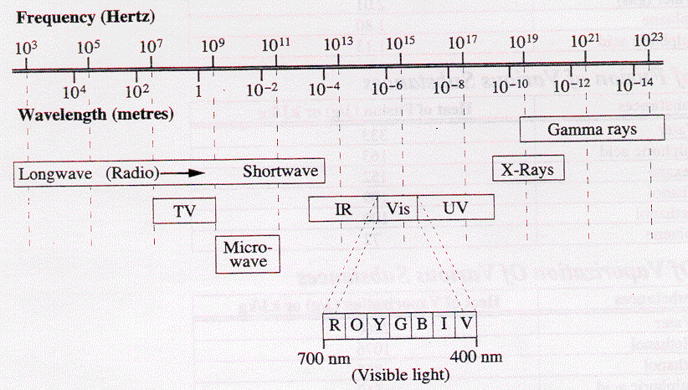
The table below shows the names that have been given to the various regions of the EM spectrum, the approximate frequency range for each region, and a brief description of the type of accelerated charge that leads to the formation of each. Note, you are responsible for
- knowing the various members of the electromagnetic spectrum and their approximate range of frequency or wavelength.
- knowing how each type of radiation is produced and detected.
- using the universal wave equation c = λ f to calculate wavelengths and frequencies of any EMR.
The Electromagnetic Spectrum
Type of Radiation | Frequency Range (Hz) | Origin of Radiation | Applications or Effect of Radiation
low frequency AC | ~60 | weak radiation emitted from AC power lines | causes interference in radio reception when passing near high voltage transmission lines
radio, radar, TV | 10⁴ – 10¹⁰ | oscillations in electric circuits containing inductive and capacitive components | transmission of radio and TV communication signals; ship and aircraft navigation by radar; reception of radio waves from outer space by radio telescopes; control of satellites and space probes
microwaves | 10⁹ – 10¹² | oscillating currents in special tubes and solid state devices | long range transmission of TV and other telecommunication information; cooking in microwave ovens
infrared radiation | 10¹¹ –  4 x 10¹⁴ | transitions of outer electrons in atoms and molecules | causes the direct heating effect of the sun and other radiant heat sources; used for remote sensing and thermography
visible light | 4 x 10¹⁴ –  7.5 x 10¹⁴ | higher energy transitions of outer electrons in atoms | radiation that can be detected by the human eye
ultraviolet radiation | 7.5 x 10¹⁴ –  10¹⁷ | even higher energy transitions of outer electrons in atoms | causes fluorescence in some materials; causes "tanning" of human skin; kills bacteria; and aids in the synthesis of vitamin D by the human body
x-rays | 10¹⁷ – 10²⁰ | transitions of inner electrons of atoms or the rapid deceleration of high energy free electrons | easily penetrates soft tissue but are absorbed by denser tissue, like bones and teeth, to produce X-ray images of internal body structures; also used for radiation therapy and non-destructive testing in industry
gamma (γ) rays | 10¹⁹ – 10²⁴ | spontaneous emission from nuclei of atoms; sudden deceleration of very high energy particles from accelerators | treatment for localized cancerous tumors
cosmic rays | > 10²⁴ | bombardment of Earth's atmosphere by very high energy particles from outer space
As an aid to help you remember the important parts of the electromagnetic spectrum you should memorize these three things:
- Remember 700 nm (red) to 400 nm (violet).
- ROYGBIV
- The following table:
Note that each frequency type goes up by a factor of 10² so you only have to memorize the order and the starting frequency. To find the equivalent wavelengths, use the universal wave equation. Recall that the speed of all forms of light/EMR is 3.00 x 10⁸ m/s.
EM type | Frequency (Hz)
TV  Microwave  Infra Red  Visible  UV  X-rays  Gamma | 10⁸  10¹⁰  10¹²  10¹⁴  10¹⁶  10¹⁸  10²⁰

Hand-in assignment
1. Electromagnetic radiation (EMR).
A. What is the fundamental origin of all EMR?
B. If a charge undergoes simple harmonic oscillations, what is the relationship between the frequency of oscillation and the frequency of the EMR produced?
C. What is the speed of all EMR?
D. Draw a sketch of an EM wave.

2. Why are radio waves, visible light waves, X-rays, etc. referred to as electromagnetic radiation?

3. Which types of radiation are caused by (a) oscillations in circuits, (b) transitions of outer electrons, (c) transitions of inner electrons, and (d) radioactivity.

4. How are radio waves similar to visible light waves? How are they different?

5. How are X-rays similar to visible light waves. How are they different?

6. As the frequency of waves increases the wavelength __________ . The range of wavelengths for visible light is from __________ to __________. Which type of wave would penetrate the human body more easily, X-rays or gamma rays (circle correct response)?

7. How do microwaves cook your food? What other application are microwaves used for?

8. At night time, to what type of light should a camera be sensitive in order to "see" people walking across a field? Explain.

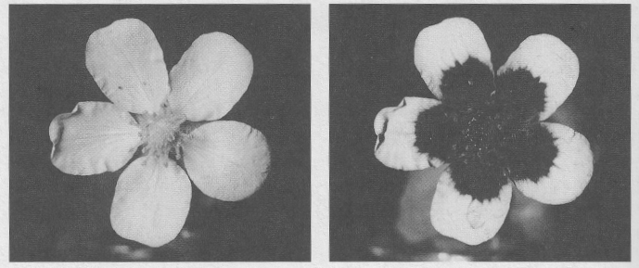
9. The left picture is a flower as it is seen in the visible part of the spectrum for humans. The flower on the right is as it appears in the low UV part of the spectrum. What type of light are honey bees most sensitive to?

10. How are X-rays used to take pictures of bones or teeth?

11. An electromagnetic wave is travelling straight up perpendicular to the Earth’s surface. If its electric field is oscillating in an east-west plane, what is the direction of oscillation for the magnetic field?

12. Calculate the quantity indicated for each of the following electromagnetic waves:
A. The frequency of a 1.8 cm microwave. (1.7 x 10¹⁰ Hz)
B. The wavelength of a 3.2 x 10¹⁰ Hz radar signal. (9.4 mm)
C. The distance between adjacent maxima of magnetic field strength in the electromagnetic wave coming from a 60 Hz transmission line. (5.0 x 10⁶ m)
D. The frequency of red visible light of wavelength 650 nm. (4.6 x 10¹⁴ Hz)

13. Two football fans are listening to a Grey Cup game on radio, one in Montreal where it is being played, and the other in the Northwest Territories, 6000 km away. The distant signal is transmitted by microwaves using a communications satellite at an altitude of 36000 km and halfway between the fans. Making whatever assumptions seem reasonable, determine how much sooner the fan in Montreal hears the results of any play. (0.24 s)

14. What is the wavelength of a certain EMR that has a period of 5.65 x 10⁻¹¹ s? (0.0170 m)

15. Ultraviolet light has a wavelength of 11.0 nm in air. What is its wavelength in glass (n = 1.52)? (7.24 nm)

16. A certain EMR has a wavelength of 7.30 x 10⁻⁸ m in air. What is its period in Lucite (n = 1.50)? (2.43 x 10⁻¹⁶ s)

17. A planet is 7.60 x 10¹² m from Earth. How long will it take a radio signal to travel to this planet and back? (5.07 x 10⁴ s)

18. A student produced an interference pattern using microwaves by placing a double slit in front of a microwave generator. If the slits are 5.00 cm apart and the antinodes of the pattern are 14.5 cm apart at a distance of 1.50 cm from the slits, what is the frequency of the microwaves? (6.03 x 10⁹ Hz)

19. Microwaves with a frequency of 8.00 x 10¹⁰ Hz pass through a double slit that has a slit separation of 3.00 cm. What is the angle of deviation of the first order maximum and the first order minimum? (7.2º, 3.6º )

20. Astronomers have detected very intense signals coming from clouds of hydrogen gas in our galaxy. The wavelengths of these signals are 1.35 cm and 18 cm. What are the frequencies of this radiation and what part of the electromagnetic spectrum would they belong to? (2.22 x 10¹⁰ Hz, 1.7 x 10⁹ Hz, microwaves)

21. Each of the following statements is either incomplete or false in some way. Rewrite each statement and explain your correction.
a) The source of all electromagnetic radiation is an accelerating particle.
b) Electromagnetic radiation having a frequency of 1.0 x 10¹⁵ Hz would be classified as infrared radiation.
c) When an electromagnetic wave passes from one material into another with a higher index of refraction, its frequency will increase.

